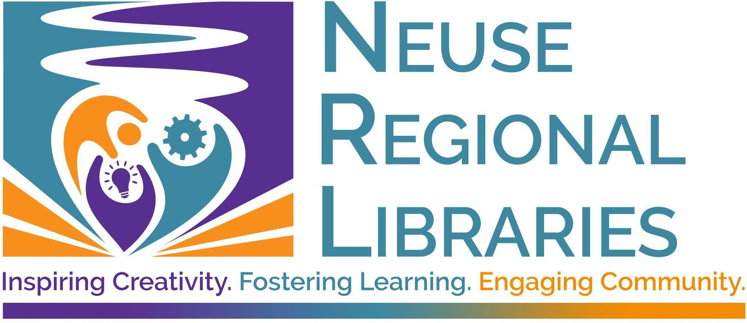
Request for Reconsideration of a Library Resource

Date Name Phone Address City State Zip Email
Library Card Number _________________
Do you represent: ▢ yourself ▢ an organization? Which organization?
Have you read the relevant Neuse Regional Libraries policy (Collection Development or Programming) in its entirety?
▢ Yes ▢ No
What type of resource are you recommending for reconsideration?
▢ Book ▢ Audiobook ▢ Magazine ▢ Newspaper ▢ Movie
▢ Library Program ▢ Other

If you selected other, please describe: If you are commenting on an item, what is the title and author/performer/producer?

If commenting on a program, what is the title and date?

How did this resource come to your attention? (Recommended by a staff member, review, friend’s recommendation, found on the shelf, visited Library, publicity announcement, calendar of events listing, social media, etc.)

Did you read, listen to or view the entire work or stay for the entire program? If not, what selection or part did you read or view?

What are the specific matters that concern you? (Please be as specific as possible; cite pages, excerpts, or scenes when possible)

Are there resource(s) you suggest to provide additional information and/or other viewpoints on this topic?

What action do you want to be taken regarding this resource?

Thank you for your comments. A member of our staff will contact you regarding your concerns. Use the back of this page for further comments if necessary.

Mail completed form to

Neuse Regional Libraries
Attn: Director of Libraries
510 North Queen Street
Kinston, NC 28501

or email to nrl@neuselibrary.org.

Signature:

Date:

